

Analysis document

codedCoffee



ITRW 213-Report 3

MARCO TALJAARD 26694379, CLARISE BOUWER 26152673, DYLAN JANSEN VAN VUUREN 26009528, QUINTIN JACOBS 26147629, ZANDER JAGALS 25855883, BRAAM VAN DER BERG 25849182, STEFAN MALAN 26128225

Table of Contents

1. Introduction 1

1.1 Project Description 1

1.2 System Requirements 1

1.2.1 Hardware Requirements 1

1.2.2 Software Requirements 2

2. Use-Case 2

2.1 Use-Case List 2

2.1 High-Level Use-Case Narratives 4

3. Data Models 12

3.1 Context Data Model 12

3.2 Key-Based Data Model 13

3.3 Fully Attributed Data Model 14

4. CRUD Matrix 15

5. Process Models 17

6. Examples of Prototype 21

6.1 The Login Interface 21

6.2 Main Interface 22

6.3 Secondary Interfaces 23

6.4 Database Prototype 26

7. Summary 28

Bibliography 29

List of Figures

Figure 1: Context Data Model 12

Figure 2: Key-Based Data Model 13

Figure 3: Fully Attributed Data Model 14

Figure 4: CRUD Matrix 16

Figure 5: Order Process Model 18

Figure 6: Stock Process Model 19

Figure 7: Sales Process Model 20

Figure 8: Login Interface 21

Figure 9: Main Interface 22

Figure 10: Add User Interface 23

Figure 11: Stock Interface 24

Figure 12: Employee Interface 25

Figure 13: Sale Interface 25

Figure 14: Branches Table 26

Figure 15: Employees Table 26

Figure 16: Orders Table 27

Figure 17: Stock Table 27

Figure 18: Sales Table 28

# 1. Introduction

System analysis can be defined as “the process of studying a procedural business in order to identify its goals and purposes and create systems and procedures that will achieve them in an efficient way” (Merriam-Webster’s Learner’s Dictionary, 2016). The following is the analysis document for stockI.T, a system being developed by codedCoffee:

## Project Description

stockI.T is a system that manages sales, stock and services. The system should be able to add stock as it is being scanned in. It should also remove stock that has been sold and update the quantity of existing stock. It should also allow the user to update the details of that stock. The system should also reduce the workload of employees and increase their work-speed by automating tedious activities. stockI.T’s user interface should be simplistic and easy to understand to improve the user-friendliness of the system. It should also keep queries as small and specific as possible to increase the overall reaction time of the system. The information gathered from these queries should be displayed in an easy to understand way to furthermore increase the speed of the system. The queries should be designed in such a way that the user is forced to accurate and valid data into the system, to reduce human errors.

The only cost associated with stockI.T is the upgrading cost of the existing computer hardware and software and possibly acquisition of additional computers. The system should establish and maintain a high level of security, for instance controlling the access that different users have to certain functions of the system. It should also increase the overall efficiency of the user by providing ease of access to the data. In order for the system to be able to achieve this and to increase the overall accuracy of the data, the database will have to be redesigned to be more simplistic and specific. By doing all of the above, the system will improve the services provided by the company leading to more satisfied customers.

## 1.2 System Requirements

### 1.2.1 Hardware Requirements

To run the system optimally the following hardware will be required:

* RAM: 4GB DDR3 1666Hz
* CPU: i3 2.5GHz 4-series
* Motherboard: Any motherboard compatible with the other components
* Storage: 500GB
* PSU: 450kW Bronze Certified

### 1.2.2 Software Requirements

To run the system optimally the following software will be required:

* Operating system: Windows 7 or higher
* MySQL Server: Any edition

# 2. Use-Case

## 2.1 Use-Case List

A use-case is defined as a “behaviorally related sequence of steps (a scenario), both automated and manual, for the purpose of completing a single business task” (Bentley, 2007:246). The following is a list of all the related use-cases of stockI.T:

|  |  |  |
| --- | --- | --- |
| Use-Case Name | Use-Case Description | Participating Actors and Roles |
| Add Stock | This use-case describes the event where the user adds stock. Extends and initiates the verify stock use-case. | * Employee (Primary business) * Manager (Primary business) * Warehouse(External receiver) |
| Cancel Order | This use-case describes the event where the user cancels an order. Depends on the revise order use-case. | * Manager (Primary business) * Supplier (External server) |
| Login | This use-case describes the event where a user logs into the system. Initiates the verify-user use-case. | * Employee (Primary business) * Manager (Primary business) |
| Make Product Inquiry | This use-case describes the event where either the manager or customer makes an inquiry about a specific product. | * Customer (External receiver) * Manager (Primary business) * Supplier (External server) |
| Make Purchases | This use-case describes the event where the customer makes a purchase. Extends the remove stock use-case. | * Customer (External receiver) * Employee (Primary business) |
| Make Purchase History Inquiry | This use-case describes the event where the manager makes an inquiry about the purchase history to the supplier. | * Manager (Primary business) * Supplier (External server) |
| Place Order | This use-case describes the event where either the manager or employee places a new order. Depends on the revise order use-case. | * Manager (Primary business) * Employee (Primary business) * Supplier(External server) * Warehouse(External receiver) |
| Place Special Order | This use-case describes the event where the customer initiates a special order. Extends the place order use-case. | * Customer (External receiver) * Employee (Primary business) * Supplier(External Server) * Warehouse(External receiver) |
| Remove Stock | This use-case describes the event where the manager initiates this use-case via the verify stock use-case to remove stock. Depends on the verify stock use-case. | * Manager (Primary business) * Warehouse(External receiver) |
| Revise Order | This use-case describes the event where the manager or supplier revise the details and legitimacy of an order. Depends on the place order use-case. | * Manager (Primary business) * Supplier (External server) |
| Update Stock | This use-case describes the event where the manager initiates this use-case via the verify stock use-case to update the details of the stock. Depends on the verify stock use-case. | * Employee (Primary business) * Manager (Primary business) |
| Update User | This use-case describes the event where the manager adds or removes a user or changes a current user’s details. | * Manager (Primary business) |
| Verify Promotion | This use-case describes the event where the customer wants to make a purchase based on a promotion. Extends the make purchases use-case. | * Employee (Primary business) * Customer(External receiver) |
| Verify Stock | This use-case describes the event where the manager wants to verify numbers and legitimacy of stock. | * Employee (Primary business) * Manager (Primary business) |
| Verify User | This use-case describes the event where a user that is attempting to log in, is validated for existence. | * None |

## 2.1 High-Level Use-Case Narratives

A use-case narrative is a “textual description of the business event and how the user will interact with the system to accomplish the task” (Bentley, 2007:246). Use-case narration is an important phase of use-case modeling. It is used to describe the path a system takes to meet a requirement. It can help to easier identify faults and misunderstandings in the system. Accurate use-case narrations also increase the accuracy of later diagrams and improve the success rate of the project. The use-case narrations for stockI.T is as follows:

Author(s): codedCoffee Date: 18 May 2016

Version: CCSI.V.01

|  |  |  |
| --- | --- | --- |
| Use-Case Name: | Add Stock | Use-Case Type  Business Requirements: |
| Use-Case ID: | CCSI-ID-001 |
| Priority: | Medium |
| Source: | Employee  Manager |
| Primary Business Actor: | * Employee * Manager | |
| Other Participating Actors: | * Warehouse(External receiver) | |
| Other Interested Stakeholders: | * Procurement – Interested in stock levels of company | |
| Description: | This use-case describes the event where an employee or manager adds new or updates the stock used by the company/branch. The information read into the database is verified and duplicates or faulty values are “red flagged”. Stock that is already in the database gets an increase in quantity. | |

Author(s): codedCoffee Date: 18 May 2016

Version: CCSI.V.01

|  |  |  |
| --- | --- | --- |
| Use-Case Name: | Cancel Order | Use-Case Type  Business Requirements: |
| Use-Case ID: | CCSI-ID-002 |
| Priority: | Medium |
| Source: | Manager |
| Primary Business Actor: | Manager | |
| Other Participating Actors: | * Supplier(External server) | |
| Other Interested Stakeholders: | * Management – Interested in order activity of company for evaluation of company performance | |
| Description: | This use-case describes the event where a manager cancels an order made by the company/branch. The managers work id and name are used to verify his authority before the cancelation is performed. A reason for the cancelation must be given by the manager. The managers work details as well as the reason for cancelation are saved and emailed to HQ for revision. If HQ deem the cancelation as acceptable a cancelation order is sent to the supplier. | |

Author(s): codedCoffee Date: 18 May 2016

Version: CCSI.V.01

|  |  |  |
| --- | --- | --- |
| Use-Case Name: | Login | Use-Case Type  Business Requirements: |
| Use-Case ID: | CCSI-ID-003 |
| Priority: | High |
| Source: | Employee  Manager |
| Primary Business Actor: | Employee  Manager | |
| Other Participating Actors: | N/A | |
| Other Interested Stakeholders: | * Management – Interested in the security of their software | |
| Description: | This use-case describes the event of when a user attempts to gain access to the system. The user is required to enter a username and password. If the username and/or password are incorrect access to the system is denied. If the username and password are verified the user is allowed access to the system but only to the functions according to the users access level. | |

Author(s): codedCoffee Date: 18 May 2016

Version: CCSI.V.01

|  |  |  |
| --- | --- | --- |
| Use-Case Name: | Make Product Inquiry | Use-Case Type  Business Requirements: |
| Use-Case ID: | CCSI-ID-004 |
| Priority: | Low |
| Source: | Customer  Manager |
| Primary Business Actor: | Manager | |
| Other Participating Actors: | * Customer(External receiver) * Supplier(External server) | |
| Other Interested Stakeholders: | N/A | |
| Description: | This use-case describes the event where a manager makes an inquiry about a product to the supplier or where a customer makes an inquiry about a product to the employee or manager. When an inquiry is made by the manager the item name and id are entered and verified. If the details of the item is verified an email containing the items’ id and name are sent to the supplier. When a customer makes an inquiry to an employee the employee enters the items’ id and name. If the details are verified all relevant information about the item is displayed. | |

Author(s): codedCoffee Date: 18 May 2016

Version: CCSI.V.01

|  |  |  |
| --- | --- | --- |
| Use-Case Name: | Make purchases | Use-Case Type  Business Requirements: |
| Use-Case ID: | CCSI-ID-005 |
| Priority: | High |
| Source: | Customer |
| Primary Business Actor: | Employee | |
| Other Participating Actors: | * Customer(External receiver) | |
| Other Interested Stakeholders: | * Management – Interested in the sales of goods made by the company to evaluate company performance and success * Procurement – Interested in sales of goods to replenish inventory | |
| Description: | This use-case describes the event where the customer purchases goods from the branch/company. The goods being purchased are scanned into the computer by the employee (cashier). Once the sale is finalized and the customer has successfully paid for the purchased goods, the goods are removed from the stock of the branch. | |

Author(s): codedCoffee Date: 18 May 2016

Version: CCSI.V.01

|  |  |  |
| --- | --- | --- |
| Use-Case Name: | Make purchase history inquiry | Use-Case Type  Business Requirements: |
| Use-Case ID: | CCSI-ID-006 |
| Priority: | Low |
| Source: | Manager |
| Primary Business Actor: | Manager | |
| Other Participating Actors: | * Supplier(External server) | |
| Other Interested Stakeholders: | * Management – Interested in the amount of money spent on inventory purchased. Evaluation of popularity of products purchased. | |
| Description: | This use-case describes the event where the manager makes an inquiry to the supplier of the purchase history. The work id and name of the manager are entered and verified. If the work id and name of the manager are correct, the time frame of the inquiry as well as the stock types to be listed are sent via an email to the supplier. | |

Author(s): codedCoffee Date: 18 May 2016

Version: CCSI.V.01

|  |  |  |
| --- | --- | --- |
| Use-Case Name: | Place order | Use-Case Type  Business Requirements: |
| Use-Case ID: | CCSI-ID-007 |
| Priority: | Medium |
| Source: | Employee  Manager |
| Primary Business Actor: | Employee  Manager | |
| Other Participating Actors: | * Supplier(External server) * Warehouse(External receiver) | |
| Other Interested Stakeholders: | * Procurement – Interested in the level of inventory * Finance – Interested in the amount of equity spent on stock. | |
| Description: | This use-case describes the event of when an employee or manager places an order. The work id and name of the user trying to place the order is verified. If the details are verified the items’ id and name is searched to determine whether there is any stock in storage. If there is no stock of the item the amount required and a reason for the placement of the order is sent via email to HQ. If HQ determines the placement of the order to be valid an email containing the items’ id, name and the amount needed is sent via email to the supplier. | |

Author(s): codedCoffee Date: 18 May 2016

Version: CCSI.V.01

|  |  |  |
| --- | --- | --- |
| Use-Case Name: | Place special order | Use-Case Type  Business Requirements: |
| Use-Case ID: | CCSI-ID-008 |
| Priority: | Medium |
| Source: | Customer |
| Primary Business Actor: | Employee | |
| Other Participating Actors: | * Customer(External receiver) * Supplier(External Server) * Warehouse(External receiver) | |
| Other Interested Stakeholders: | * Procurement – Interested in the inventory level of the company | |
| Description: | This use-case describes the event where the customer requests a special order from the employee. The work id and name of the employee trying to place the order is verified. If the details are verified the items’ id and name is searched to determine whether there is any stock in storage. If there is no stock of the item an email containing the items’ id, name and the amount needed is sent via email to the supplier. An email is also sent to the customer verifying the order. The order is recorded and saved for future reference. | |

Author(s): codedCoffee Date: 18 May 2016

Version: CCSI.V.01

|  |  |  |
| --- | --- | --- |
| Use-Case Name: | Remove stock | Use-Case Type  Business Requirements: |
| Use-Case ID: | CCSI-ID-009 |
| Priority: | Medium |
| Source: | Manager |
| Primary Business Actor: | Manager | |
| Other Participating Actors: | * Warehouse(External receiver) | |
| Other Interested Stakeholders: | * Procurement – Interested in the levels of inventory within the business. | |
| Description: | This use-case describes the event where the manager removes faulty, fake or incorrect stock. The work id and name of the manager are entered and used to verify the users’ access level and legitimacy. If the id and name are verified the user selects the stock to be removed. A reason for the removal as well as the item id and name are sent via email to HQ. If HQ approves of the removal an email containing the item id and name is sent to the warehouses. | |

Author(s): codedCoffee Date: 18 May 2016

Version: CCSI.V.01

|  |  |  |
| --- | --- | --- |
| Use-Case Name: | Revise Order | Use-Case Type  Business Requirements: |
| Use-Case ID: | CCSI-ID-010 |
| Priority: | Medium |
| Source: | Manager |
| Primary Business Actor: | Manager | |
| Other Participating Actors: | * Supplier(External server) | |
| Other Interested Stakeholders: | * Procurement – Interested in stock levels of the company | |
| Description: | This use-case describes the event where the manager revises a placed order. The managers’ work id and name are entered for verification. If the details are verified the order number and item id are entered. If the details that were entered are verified all the information concerning the order is shown to the user. If changes are made to the order, the order number and changes are sent to the supplier via email. | |

Author(s): codedCoffee Date: 18 May 2016

Version: CCSI.V.01

|  |  |  |
| --- | --- | --- |
| Use-Case Name: | Update Stock | Use-Case Type  Business Requirements: |
| Use-Case ID: | CCSI-ID-011 |
| Priority: | Medium |
| Source: | Employee  Manager |
| Primary Business Actor: | Employee  Manager | |
| Other Participating Actors: | N\A | |
| Other Interested Stakeholders: | N\A | |
| Description: | This use-case describes the event where the manager or employee changes the details of stock owned by the company. The work id and name of the user is verified. If the user has the adequate access level, the system requests the user to enter the item id and name of the stock that the user wishes to update. If the item id and name are verified the information concerning the stock is shown. Any changes made to the stock is recorded and saved as well as the date on which it was changed and the name and work id of the user who made the changes. | |

Author(s): codedCoffee Date: 18 May 2016

Version: CCSI.V.01

|  |  |  |
| --- | --- | --- |
| Use-Case Name: | Update user | Use-Case Type  Business Requirements: |
| Use-Case ID: | CCSI-ID-012 |
| Priority: | Medium |
| Source: | Manager |
| Primary Business Actor: | Manager | |
| Other Participating Actors: | N\A | |
| Other Interested Stakeholders: | * Human Resources – Interested in the information of the employees of the company | |
| Description: | This use-case describes the event where the manager adds, removes or changes the information of a user. The users’ work id and name are entered to verify that the user has the required access level. Once the details are verified the user is asked if he wants to add, remove or update a user. When a user is added or updated the information of the user is saved as well as the changes that were made. If a user is removed all relevant information is deleted. | |

Author(s): codedCoffee Date: 18 May 2016

Version: CCSI.V.01

|  |  |  |
| --- | --- | --- |
| Use-Case Name: | Verify promotion | Use-Case Type  Business Requirements: |
| Use-Case ID: | CCSI-ID-013 |
| Priority: | Medium |
| Source: | Customer |
| Primary Business Actor: | Employee | |
| Other Participating Actors: | * Customer(External receiver) | |
| Other Interested Stakeholders: | N\A | |
| Description: | This use-case describes the event where the customer wants to make a purchase based on a promotion. The item id and name are entered for verification. If the details are verified the system determines if the item is listed on the promotions list. | |

Author(s): codedCoffee Date: 18 May 2016

Version: CCSI.V.01

|  |  |  |
| --- | --- | --- |
| Use-Case Name: | Verify stock | Use-Case Type  Business Requirements: |
| Use-Case ID: | CCSI-ID-014 |
| Priority: | High |
| Source: | Employee  Manager |
| Primary Business Actor: | Employee  Manager | |
| Other Participating Actors: | N\A | |
| Other Interested Stakeholders: | N\A | |
| Description: | This use-case describes the event where the manager wants to verify the legitimacy of stock. The users’ work id and name are verified by the system. The user gets prompted to enter the items’ id and name. If the items’ details are verified all relevant information for the item as well as all the information concerning any change in the quantity of the item are shown to the user. | |

Author(s): codedCoffee Date: 18 May 2016

Version: CCSI.V.01

|  |  |  |
| --- | --- | --- |
| Use-Case Name: | Verify user | Use-Case Type  Business Requirements: |
| Use-Case ID: | CCSI-ID-015 |
| Priority: | High |
| Source: | N\A |
| Primary Business Actor: | N\A | |
| Other Participating Actors: | N\A | |
| Other Interested Stakeholders: | * Management – Interested in the security of the system | |
| Description: | This use-case describes the event where a user that is attempting to log in, is validated for existence. The username and password are entered and cross-referenced by the system to determine whether or not they exist. If the username and password exist the system sends the username, password and access level to login use-case. | |

# 3. Data Models

Data modelling is defined as a “technique for organizing and documenting a system’s data” (Bentley, 2007:309). The actual model, is often referred to as an entity relationship diagram (ERD), since it depicts the data in relation to the entities and relationships portrayed by the data. Bentley (2007:309) defines an entity as “something about which the business needs to store data”, which could include people, things, ideas, and places. In this document, stockI.T’s context, key-based and fully attributed data models will be depicted.

## 3.1 Context Data Model

A context data model is a data model that excludes attributes and only depicts entities and relationships. An attribute is a “descriptive property or characteristic of an entity” (Bentley, 2007:272), while a relationship is a natural business association between entities. Figure 1 depicts the context data model of stockI.T.

Figure 1: Context Data Model

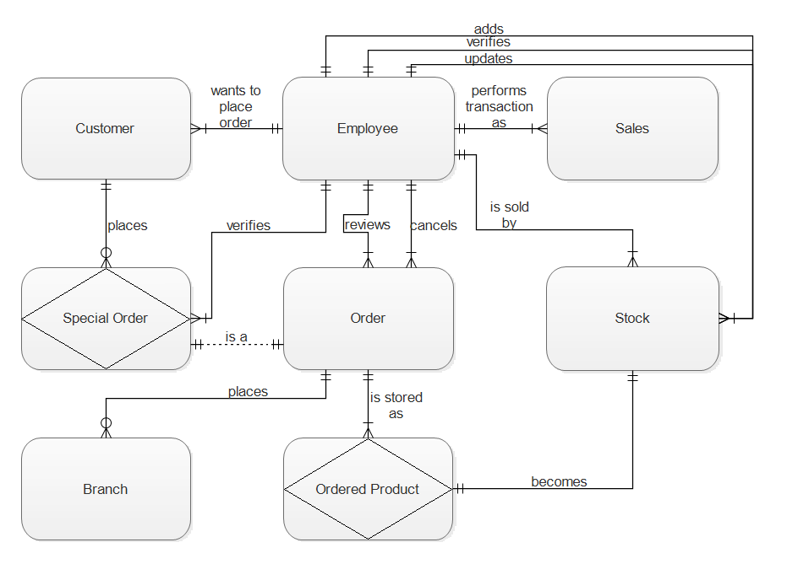

## 3.2 Key-Based Data Model

Bentley (2007:286) defines a key-based data model as a “data model that includes entities and relationships with precise cardinalities resolving non-specific relationships into associative entities, and also including primary and alternate keys”. Cardinality defines the minimum and maximum occurrences that might be associated with a single instance of another entity. Most of the relationships in stockI.T’s key-based data model is non-specific relationships, which are relationships wherein each participating entity has its own primary key. A candidate key is defined as “one of a number of keys that may serve as the primary key of an entity” (Bentley, 2007:274).

A primary key is a candidate key that will in most cases be used to uniquely identify an entity instance, while the remaining keys are known as alternate keys.

Figure 2: Key-Based Data Model

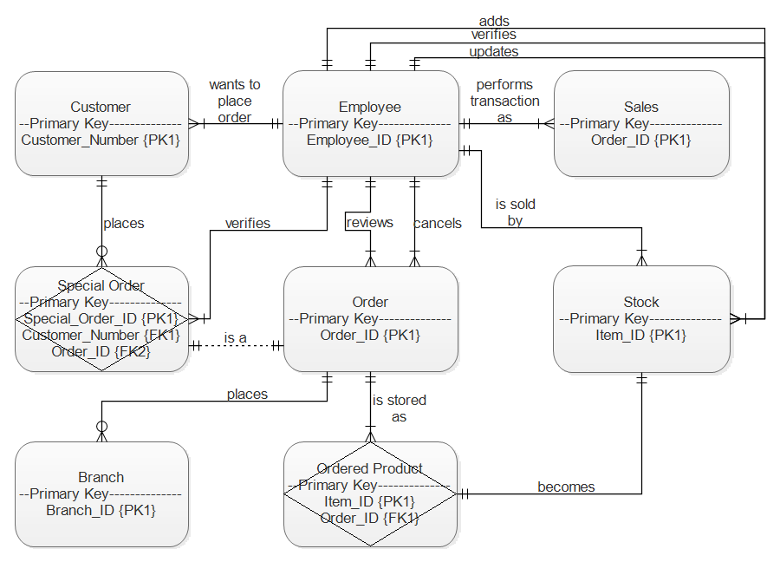

## 3.3 Fully Attributed Data Model

“A data model that includes all entities, attributes, relationships, sub setting criteria, and precise cardinalities” (Bentley, 2007:286), is known as a fully attributed data model.

Figure 3: Fully Attributed Data Model

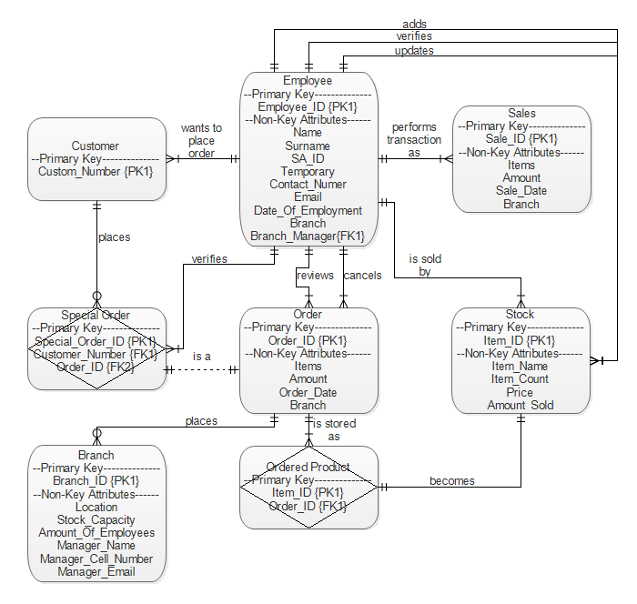

# 4. CRUD Matrix

SQL (Structured Query Language) consists of 4 statements, which are sometimes referred to as CRUD:

* Create – INSERT- to store new date
* Read – SELECT- to retrieve existing data
* Update – UPDATE- to modify or change existing data
* Delete – DELETE- to remove existing data

A CRUD matrix is a “table showing the functions in an application containing SQL statement affecting parts of a database” (Anon, 2001). This matrix is an outstanding method to identify the tables of a database which are involved in any user interaction and process. This method will reveal each table involved in any CRUD operation. It can be a very useful tool to identify bottlenecks in systems, since it shows which tables are heavily used along with those that are rarely used. Thus is it very valuable to include a CRUD matrix into the analysis of a system.

The CRUD Matrix used in this document (*Figure 4*) is a data-to-process-CRUD Matrix. This CRUD matrix shows the linkage between data and processes (Bentley, 2007:359).

Figure 4: CRUD Matrix

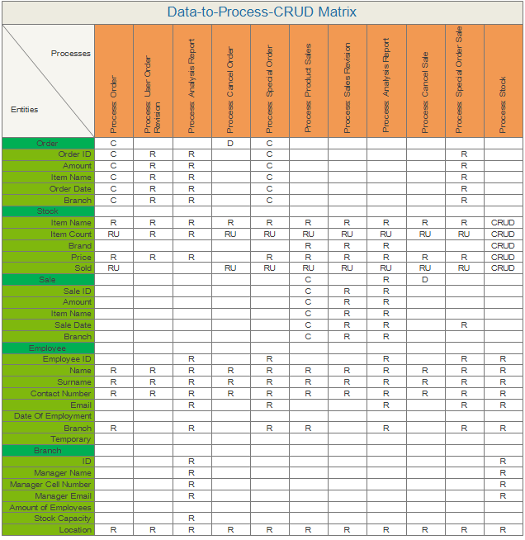

# 

# 5. Process Models

Process modelling is defined as a method that is used to document and organize a system’s processes. A process, according to Bentley (2007:322), is “work performed by the system in response to incoming data flows or conditions”. Between all the processes and external agents, there are data flows, control flows and data stores. Any external element that interacts with the system is defined as an external agent. A data flow is “data that is input or output to or from a process” (Bentley, 2007:325), while a control flow is a circumstance or non-data occurrence that triggers a process. Data stores are “stored data intended for later use” (Bentley, 2007:320).

Figure 5: Order Process Model

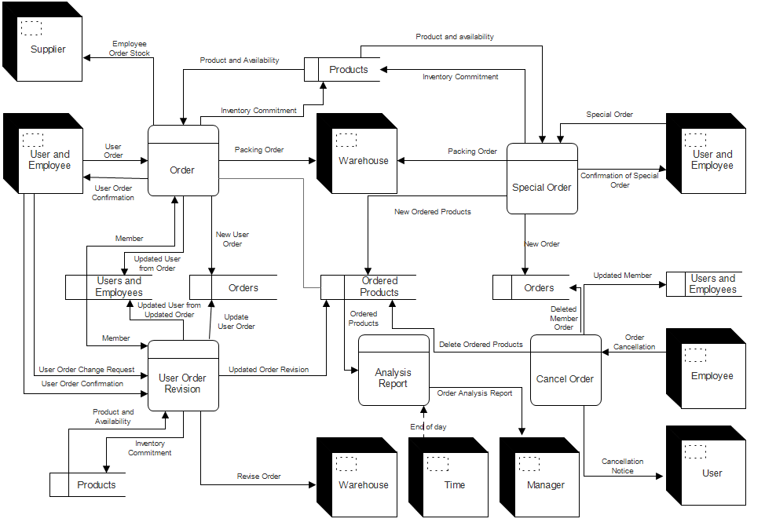

Figure 6: Stock Process Model

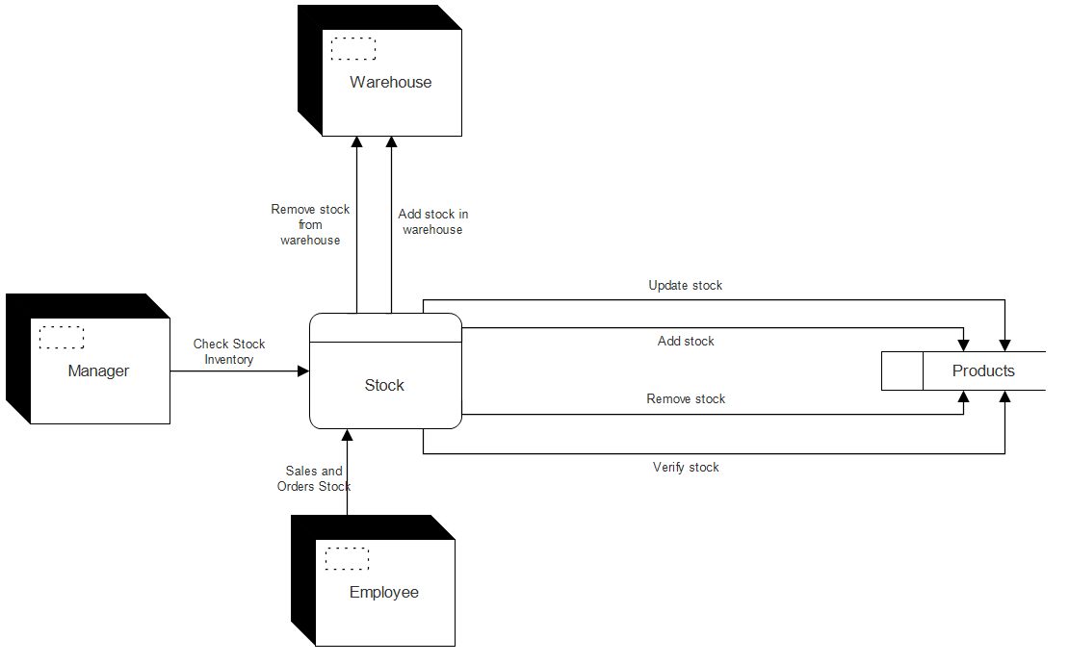

Figure 7: Sales Process Model

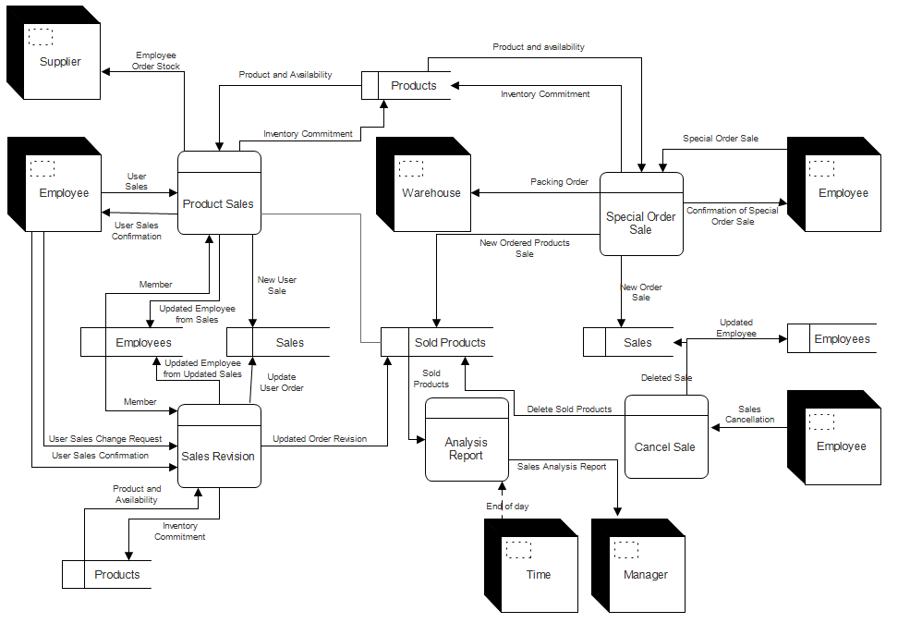

# 6. Examples of Prototype

The following figures depict the work that has been done, to date, for the stockI.T system.

## 6.1 The Login Interface

Initially when the user opens stockI.T, they will be prompted to create a new administrative account. The following is a screenshot of what the user will see when they initially open stockI.T:

Figure 8: Login Interface

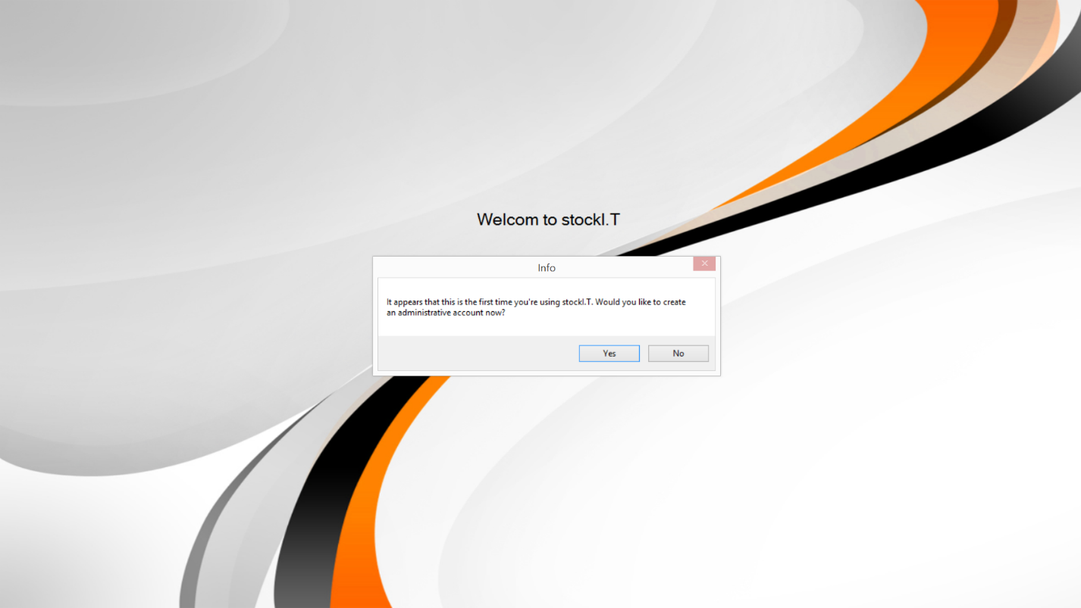

Note: The following representations and descriptions may change as the development of stockI.T progresses, as this is only the prototype which is used to test the functionality of the program.

This screen will be used in the future to log into the program and to use the program. If it is still the initial start-up, the user will have to enter a username and password to be used in the future. Since this is the administrative account, the account details will have to be remembered. If the account details are forgotten or lost, the stockI.T Support will have to be contacted to provide further support. The username can be entered according to the user’s specifications, but the password will have to meet the following conditions:

* The password must be 8 characters long
* The password may not contain a “#” or a “,” symbol

After the user has entered valid details for the account, the account will be created and the user will be required to immediately log in with the same account. After logging in they will be transferred to the following screen:

## 6.2 Main Interface

Figure 9: Main Interface

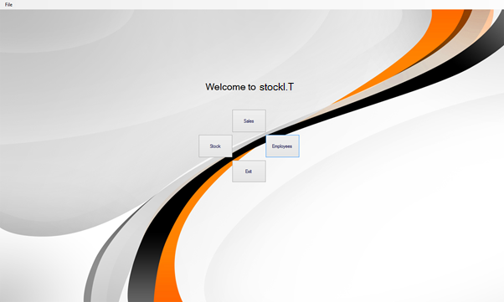

From this screen the user will be able to be transferred to each respective component’s interface, which in turn will have its own functionality. This interface will serve as a “central hub” for the rest of the interfaces.

The main interface will have to following options:

* Logout
* Stock
* Sales
* Employees
* Orders (to be added in the future)
* End of day (to be added in the future)
* Technical (to be added in the future)
* Headquarters (to be added in the future)
* Other (functions only available to an administrative account)

Whenever a user logs into or out of the system, it will be recorded in an activity log. The activity log will not only help administration to see who used the system at a specific time, but also which employee completed an activity that has a direct relation to the data of the company.

The user is also currently able to create other users through the following interface:

## 6.3 Secondary Interfaces

Figure 10: Add User Interface

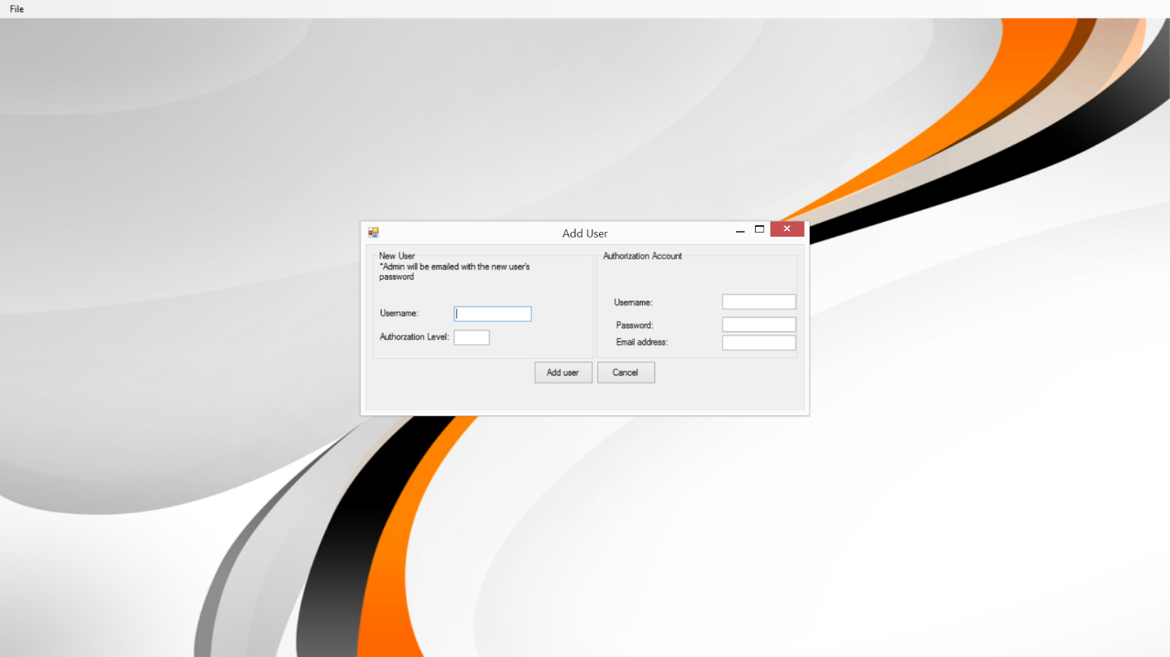

The user will be able to specify the new user’s username and its authorization level (which is used to determine to which functions the user has access to, where a 10 is the highest), but not its password. An administrative account will be required to enter its details into the right-hand side of the interface. If the new account’s username is valid and the authorization account’s detail are correct, the password of the newly created account will be e-mailed to the authorization account’s e-mail address. Within this e-mail it gives the details of the account, along with the username of the account that authorized the account to be created.

Each component on the main interface (of which there will be six in the finished version of stockI.T) will transfer the user to its respective interface. The following is a possible representation of what the finalized interfaces might look like:

Through this interface, the user will be able to add, remove, search stock.

Figure 11: Stock Interface

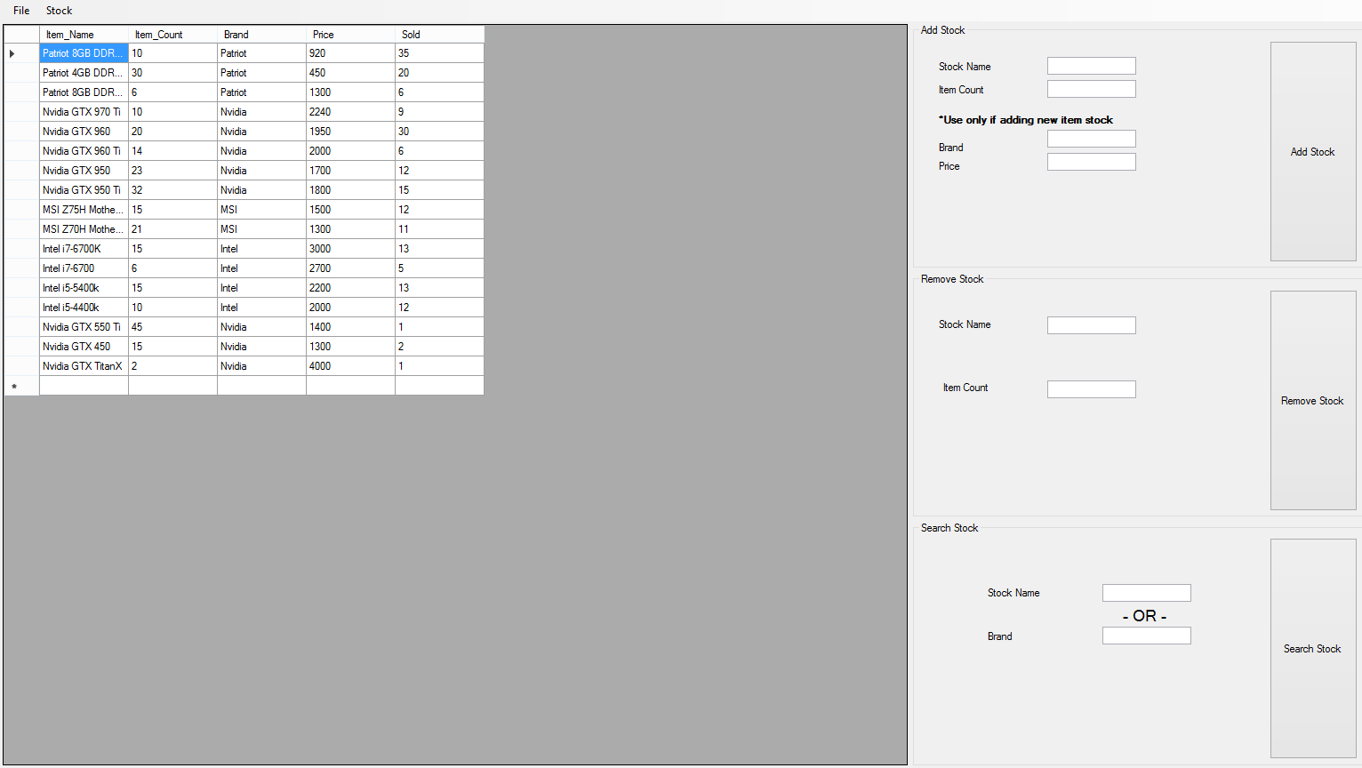

The following interface (figure 12) will allow the user to add other employees, given that they have the required authorization level. It will also allow the user to remove other employees from the company’s database and extract the details of a current employee.

Figure 12: Employee Interface

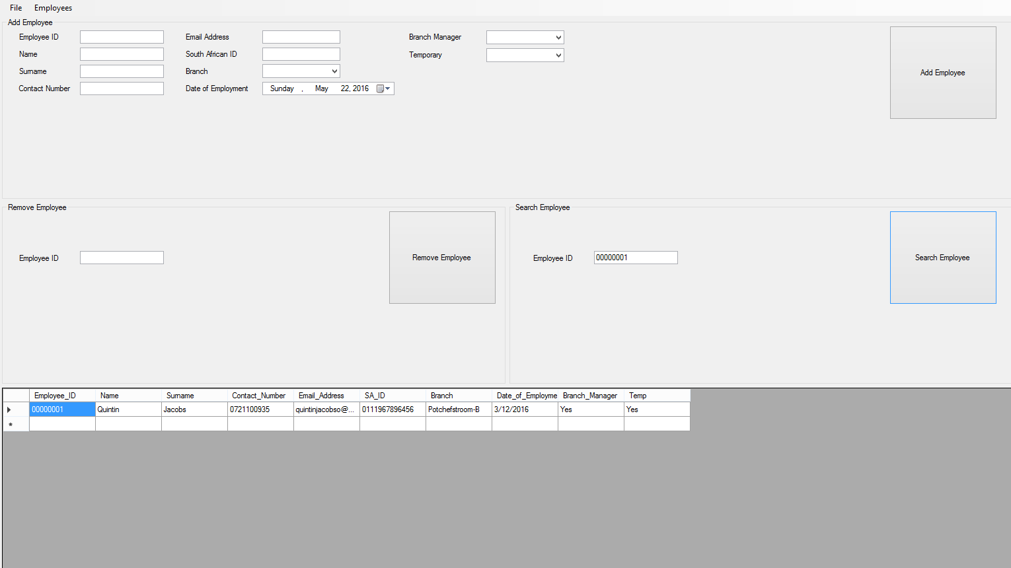

The following interface will allow the user to complete a sale by selecting the items to be sold in the “Available Stock” area. The user will also be able to review past sales for errors and validity.

Figure 13: Sale Interface

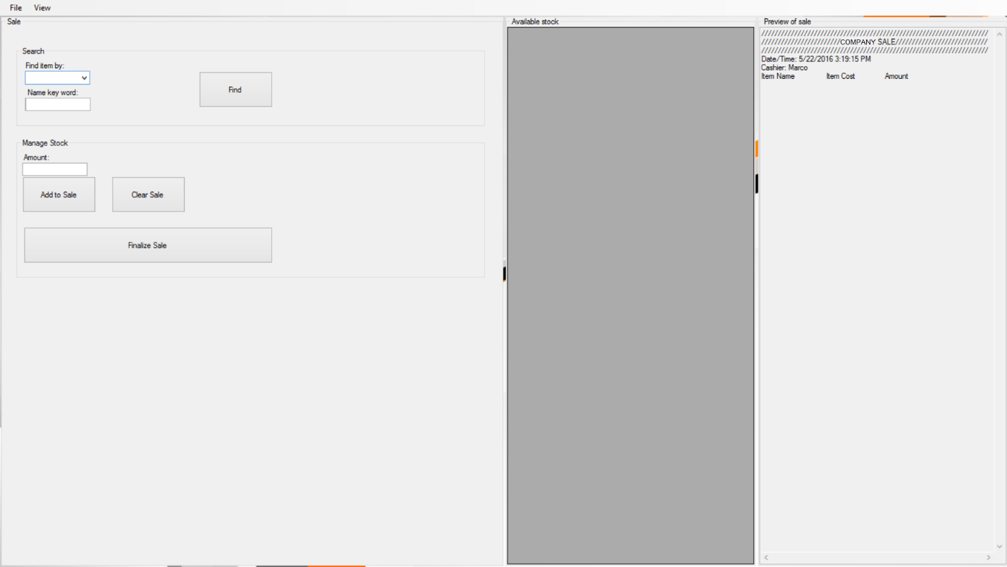

## 6.4 Database Prototype

The data in the database will be as indicated by the fully attributed data model in this document. The following are examples of data that could be present in the database:

Note: Not all data in the prototype database is valid, as the database has been mass populated with random data for the sole purpose of testing the functionality of the program.

Figure 14: Branches Table

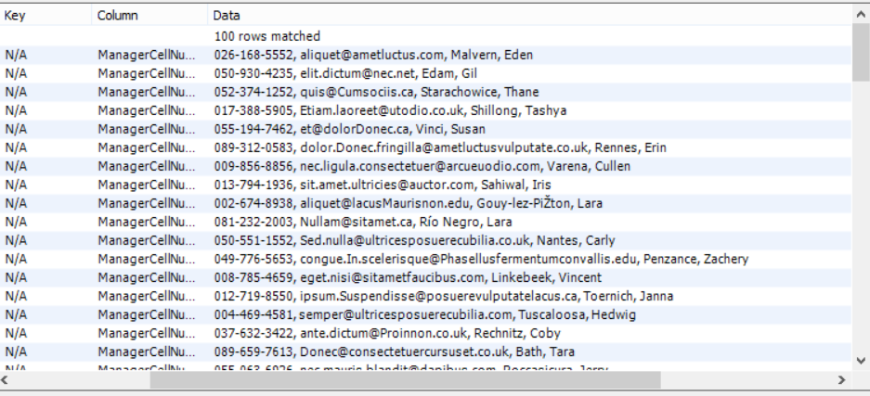

Figure 15: Employees Table

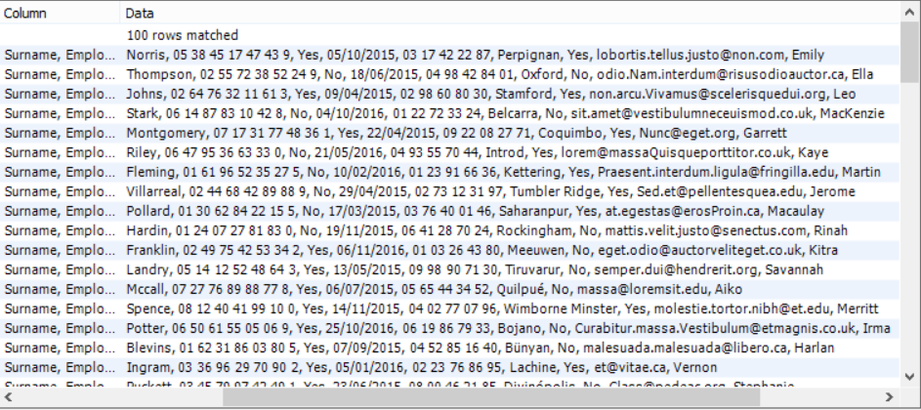

Figure 16: Orders Table

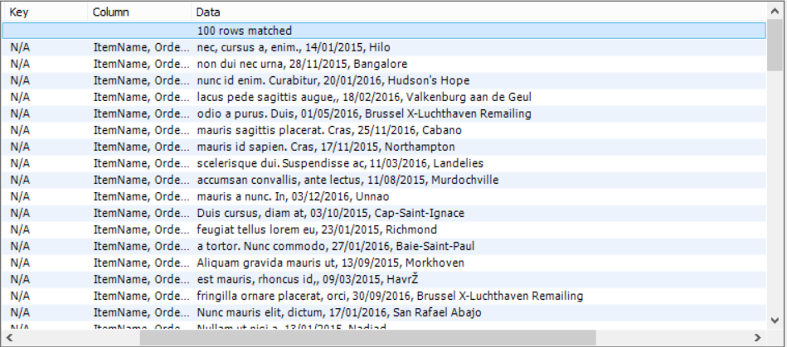

Figure 17: Stock Table

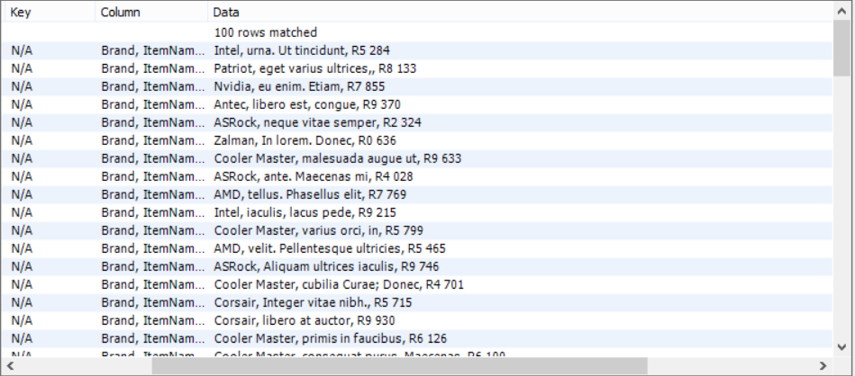

Figure : Sales Table

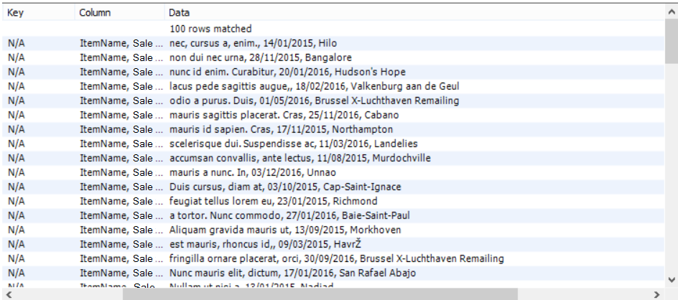

# 

# 7. Summary

As a result of the analysis of stockI.T, has a better understanding of how all of the actors and use-cases communicate and coincide, as well as when and how each use-case is initialized and used by its respective actor(s), been established. By outlining the use-case narratives the where and when of the implementation, by the system, of each use-case and their dependencies has been determined.

By depicting the data models of stockI.T, the required data for each entity has been highlighted, which allows the team to reduce redundant data processed by the system. As a result of the reduced redundancy of the data, the efficiency of the user will be increased, which is one of the main goals of the project.

By determining the interactions between the processes and attributes of the entities, the required actions of each process, as well as the data each entity has to provide, has been defined. It has also been established how each external actor is involved with each process and data store(s).The prototype has provided the team with a fixed visual idea of what the final system will look like.

# Bibliography

Anon. 2001. A CRUD Matrix. [www.databaseanswers.org/data_migration/crud_matrix.html](http://www.databaseanswers.org/data_migration/crud_matrix.html) Date of access: 21 May 2016.

Bentley, L & Whitten, J. 2007. System Analysis and Design Methods. 7th ed. McGraw Hill.

Merriam-Webster’s learner’s dictionary 2016. System Analysis. [www.merriam-webster.com/dictionary/systems%20analysis](http://www.merriam-webster.com/dictionary/systems%20analysis) Date of access: 22 May 2016